BY Maryann Cocca-Leffler

PUBLISHED BY ALBERT WHITMAN & COMPANY 2013

www.albertwhitman.com

HOW ARE YOU FEELING TODAY?

Mood cards for Mood Monday (or any day) Materials needed:

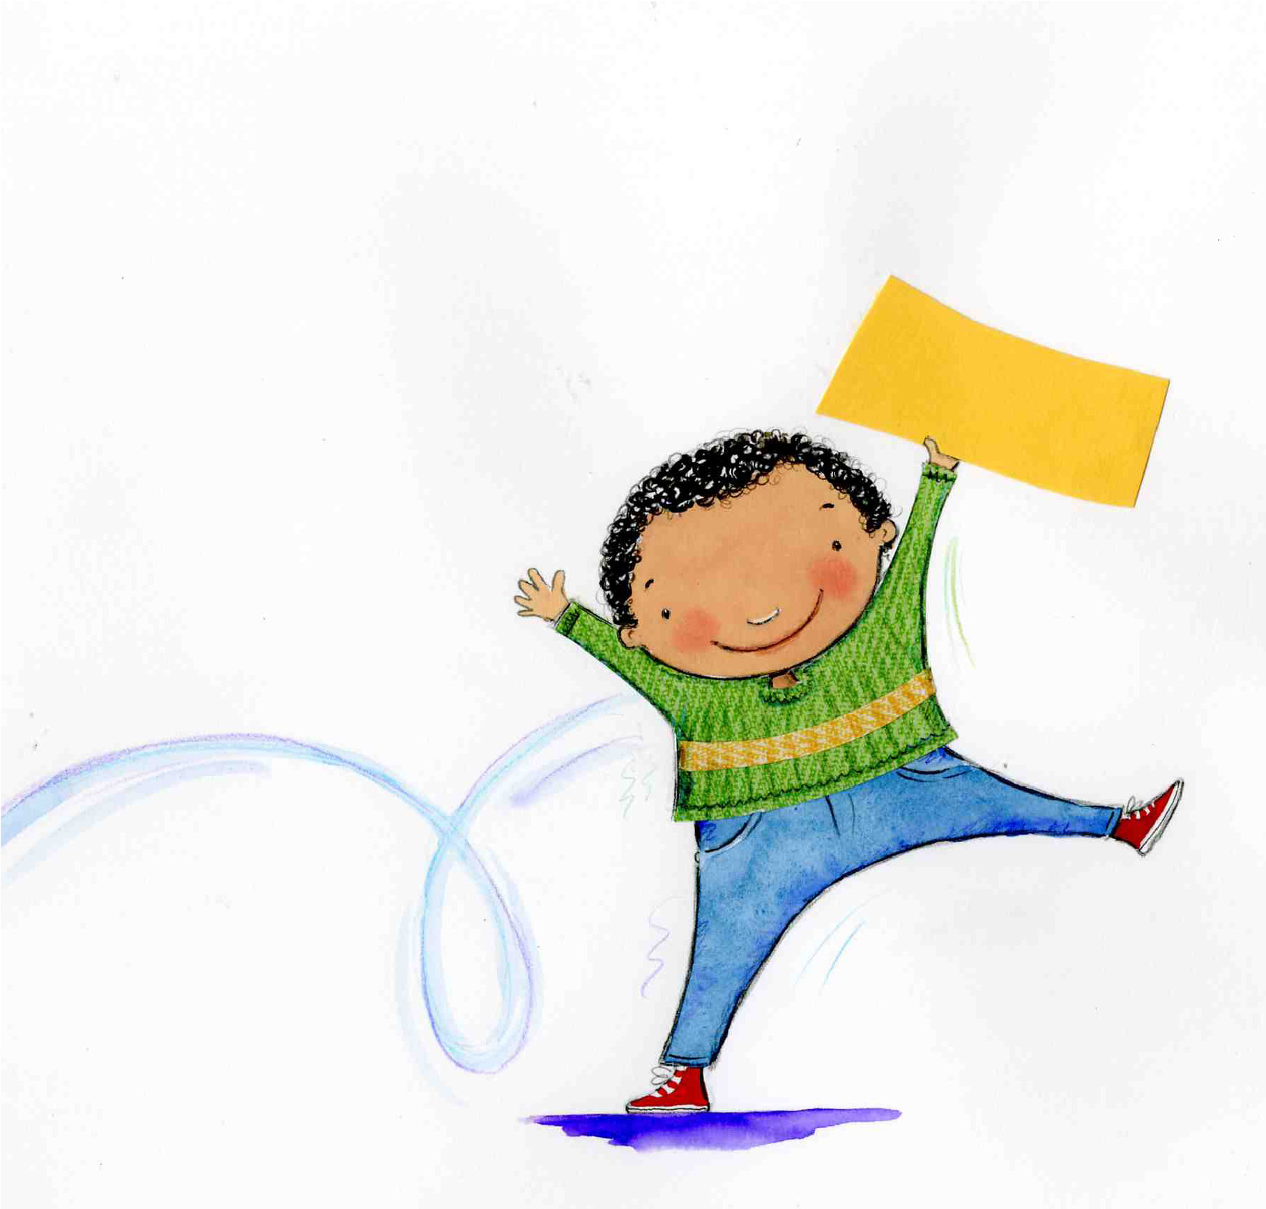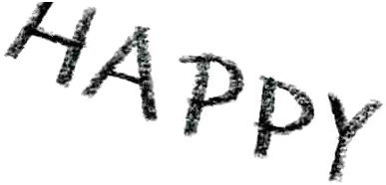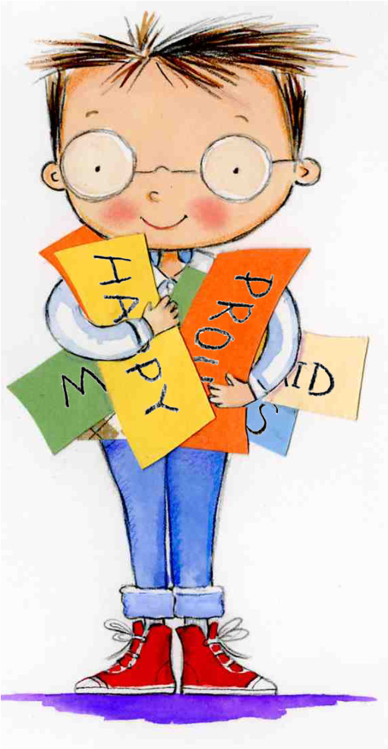

Color or decorate each card to illustrate the mood named on the card.

Be careful to keep the word visible!

Cut the cards out along the dotted lines.

Punch one hole in the upper left corner of each card.

Use a metal ring to hold the cards together.

Place each packet of mood cards on the corner of your desk.

Each morning, turn the cards to have your current mood on top!

a copy of this sheet on plain cardstock for each child participating crayons, markers, colored pencils, and/or stickers for decoration scissors hold punch metal rings

Directions:

|  |  |
| --- | --- |
| PROUD | MAD |
| JEALOUS | CHEERFUL |
| GRATEFUL | AFRAID |
| CONFUSED | HAPPY |
| BORED | EXCITED |
| SAD | LUCKY |